NEWS RELEASE
EMBARGOED – HOLD FOR RELEASE UNTIL 12:01 A.M. MARCH 7, 2017
CONTACT:
Lisa Matthews, LMatthews@hagersharp.com, (202) 706-7477
James Deaton, James.Deaton@ed.gov, (202) 245-7140

New Results from National Indian Education Study Reveals Varying Student Experiences and Flat Achievement

(WASHINGTON, DC) – Average math and reading scores for fourth- and eighth-grade American Indian and Alaska Native (AI/AN) students were released today by the National Center for Education Statistics (NCES). According to the National Indian Education Study (NIES), students’ scores have not change significantly in 2015 compared to 2005 or 2011.

Administered as part of the National Assessment of Educational Progress (NAEP), NIES is a national study endorsed across AI/AN communities that puts into context the condition of education and experiences of AI/AN students in the United States.

A national sample of approximately 17,000 fourth- and eighth-grade students participated in this study. The study separates AI/AN results into three mutually exclusive categories of schools as well as an overall category. Those three categories include: low-density public schools where less than 25 percent of students were AI/AN; high-density public schools where 25 percent or more students were AI/AN; and Bureau of Indian Education (BIE) schools. All AI/AN students include all AI/AN students sampled throughout the nation in public, private, BIE, and Department of Defense schools.

“The latest results of the NIES study provide important insights into the extent of school resources available for improving student achievement for schools of varying density,” said Dr. Peggy Carr, the acting commissioner of NCES. “We see that the overall achievement of AI/AN students has remained the same since NCES began conducting this study."
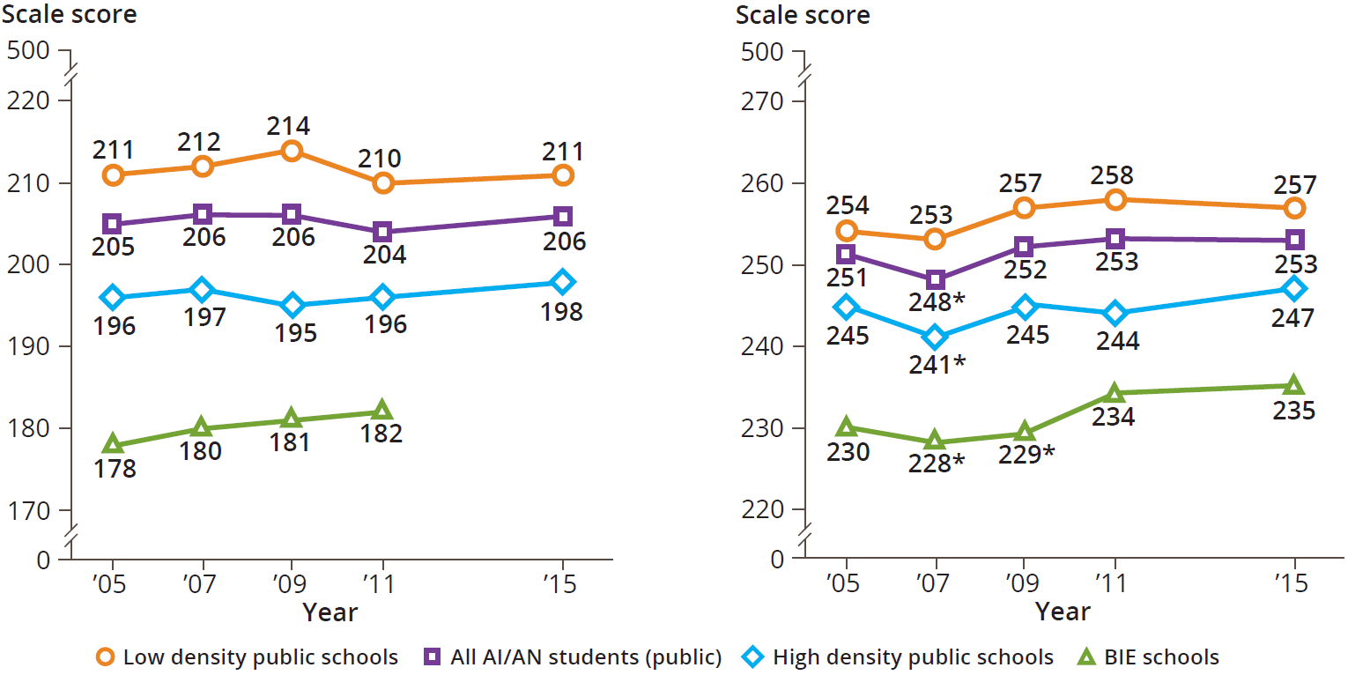
Figure 2. Trend in NAEP reading average scores for eighth-grade AI/AN students, by school type/density:
Selected years, 2005-2015
Figure 1. Trend in NAEP reading average scores for fourth-grade AI/AN students, by school type/density:
Selected years, 2005-2015

Performance results for 2015 are unavailable for BIE schools at fourth grade due to school participation rates that did not meet the 70 percent criteria. The national results show a consistent pattern in both grades 4 and 8 in reading and mathematics. AI/AN students did not show statistically different changes compared to the most recent administration of NIES in 2011 or the first administration of the study in 2005. That same pattern appeared in low-density, high-density, and BIE schools.

NIES also explored the educational experiences of AI/AN students through survey questionnaires. Students, teachers, and administrators provided insights into how schools engage with their AI/AN students and how teachers integrate culturally responsive materials, activities, and instructions into their lessons. The survey included the following topics:

- Students – knowledge of Native culture and use of language
- Teachers – knowledge of and skill development for teaching AI/AN students, culturally specific instruction, and classroom practices
- School Administrators – involvement of AI/AN community members and sufficiency and quality of books specific to AI/AN culture

All survey questions are available to the public and data from all survey questions will be available via the NIES Data Explorer, https://nces.ed.gov/nationsreportcard/niesdata/, in conjunction with the report’s release.

There are significant differences among student characteristics in all school types for both grades 4 and 8. The study also collected information about factors such as computers in the home, eligibility for National Student Lunch Program (NSLP), percentage of English language learners, and those who attend rural schools.

Findings include the following:
- Seventy-three percent of all AI/AN students at grade 4 and 66 percent at grade 8 are eligible for the National Student Lunch Program
- Eleven percent of all AI/AN students at grade 4 and 7 percent at grade 8 are English language learners
- Forty-five percent of all AI/AN students at grade 4 and 38 percent at grade 8 attend rural schools
- Sixty-nine percent of all AI/AN students at grade 4 and 75 percent at grade 8 reported having a computer in the home
- At grade 8, 40 percent of all AI/AN students reported their parents went to college

When the study began in 2005, seven states had reportable data specific to AI/AN students. The number of states with this data has since expanded and now includes: Alaska, Arizona, Minnesota, Montana, New Mexico, North Carolina, North Dakota, Oklahoma, Oregon, South Dakota, Utah, Washington, Wisconsin, and Wyoming.

###

NIES is sponsored by the Office of Indian Education, within the U.S. Department of Education’s Office of Elementary and Secondary Education, and is conducted by the National Center for Education Statistics within the Institute of Education Sciences. Executive Order 13592, signed by President Obama in December of 2011 reaffirms the mandate of Executive Order 13336 issued in 2004, which called for closer examination of the educational experiences and progress of AI/AN students as well as the promotion of research opportunities and collaboration with tribal communities. From 2005 to 2011, NIES was administered every two years. After 2011, the NIES reporting cycle was changed to every four years. NCES partnered with a variety of stakeholders in the AI/AN community, including a Technical Review Panel composed of AI/AN educators, U.S. Department of Education’s Office of Indian Education (OIE) and the White House Initiative on AI/AN Native Education. Other notable partners include the Assistant Vice President of Tribal Relations at the University of Arizona, Karen Francis-Begay, native owned businesses Kauffman & Associates, Inc., and Tribal Tech, LLC.

